What spiritual practices appeal to your one beautiful spirit?
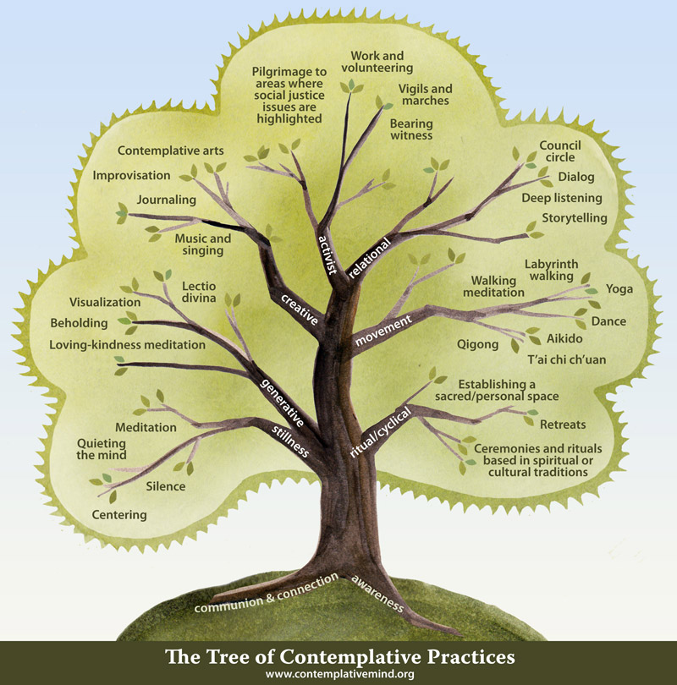
“Many millennials consider the church a place that tells you what you can or cannot do—not a place where they can affect change. …no matter its form, my hope for the future is that the church remains a place where you can go to be rejuvenated and restored, where you can be a part of a community that embraces and loves you. In order to do that, we must negotiate and balance the role of the church with tradition AND innovation, not either/or.”
From Reverend Natasha Patterson, Chaplain Resident at Emory University Hospital
See www.contemplativemind.org for info
In a typical Sunday worship service, you will encounter
from 8-12 of these contemplative practices!

Upcoming Events
- 9th Annual Friends of the Poor Run/Walk on Saturday, Oct 1 to be hosted at the
New Ipswich Congregational Church, located at 150 Main Street, New Ipswich, NH
Registration at 8 am, run/walk begins at 9 am. Proceeds go the St. Vincent DePaul Food Pantry in Greenville. To register visit www.friendsof thepoor5k.com
- Community Supper/ Harvest Supper Thursday, October 13 5:30 to 7 pm
The traditional Harvest Supper of turkey and all the trimmings lives on at Mason Church! Come to
this wonderful celebration of fall and of our abundance of blessings. Please bring a something for
the St Vincent DePaul Food Pantry to share our abundance.
- Live, and lively music at our LivingRoom Coffee House October 15 Come at 6:30 to sign up for open mic, or just to relax with a snack before the music starts at 7pm. Featuring Pat Kenneally and Rick Cooper, “folksy and fun!”

Forced from Home Oct 15-23 Long Wharf, Boston Doctors Without Borders new exhibition about the global refugee crisis—join aid workers as they guide you through a free, interactive exhibition on the global refugee crisis, sharing their experiences in the field and showing you the real-life impact of your support. Anyone want to do a church road trip?
- October 23, 3:30 in Mason Church Sanctuary Bob Griffin’s Weep with Those who Weep: a Requiem Go to www.batraxoi.com for more info. This is an opportunity to experience the wonders of our sanctuary acoustics and a creative musical performance with local talent. Go to website to listen to previous performances.

- Halloween Tailgate Party Saturday, October 29. 6pm to 8pm in Church parking lot If you would like to participate, bring some treats, open your tailgate, decorate it if you wish, dress up in costume or not, and enjoy the camaraderie of the excited little children, and the nearly as excited adults. Set up by 5:45 if you can.
- Fall Cleanup November 5 from 9-12. All help is needed for the tidy up, winterize, and more! Bring rakes, shovels, gloves, and lots of energy. Don’t sign up, Show Up!
- Soup Kitchen mission Signup sheet will be on the bulletin board. Dates are January 14, February 11, and March 11 SAVE the DATES! Our first trip in August was a great success, ask Kathy Chapman, 878-4993, about the event, and get an idea of the need, fun, and the work.
- September Yard Sale—Thank you the success of the 2016 Yard Sale at the Old Home Day Celebration. Thank you for contributions, work at organizing and selling and cleaning up!
- Do you have an update for Church Members and Friends Directory: Send corrections or additions to miscott39@gmail.com Email Michelle if you would like a copy of this directory.
- Lending Library Notice the fine bookshelf in Fellowship Hall that has books for lending—all nicely organized, and alphabetized by a church angel. Steve Tamulonis has contributed some CDs for lending/listening. Please sign them out, and return in a reasonable time. Enjoy this grace.
- Yarn into Prayer Shawls! Join the knitters of Mason Church in prayerful knitting. If you know someone who needs the warmth and prayers of a shawl please contact: Susan Suokko at Usercat2@comcast.net or 941-920-0270 or Michelle Scott 878-1680
- Curt Dunn and Karin Eisenhaure are doing a road trip to MA, to get the vegetables for the Community Supper/Harvest Supper. Thanks so very much for keeping up this tradition of generosity, and great vegetables/potatoes.
- Dotsie Millbrandt Please keep the family in prayer. Dotsie is very busy with care of both Wolfgang and his mother, Archie the dog, and the ducks! Emails and cards are welcome. She will let us know how else we can assist. Dotsie24@gmail.com or 1322 Starch Mill Rd, Mason, NH 03048.
- Joe and Jennie Walsh and Joshua, Jonathan and Joseph are always in our hearts and thoughts. Recently Joe has been hospitalized again to treat his many, as yet unknown, allergies. Their address is: 50 Clinton Ave, Chelmsford, MA 01824 978-256-6700 Jwalsh131@comcast.net
- Remember Arthur Rafter. Arthur is in Milford at Ledgewood Assisted Living. His address is: 43 Ledgewood Dr. Milford, NH 03055 Ledgewood phone 672-5037
- Cindy Tibbetts Cindy and Jim have sold their house, and moved to Milford. We celebrate with them, as Cindy will be able to get around somewhat better up in Milford, though Mason will be missing her in so very many ways. She may need rides to church when Jim or her parents can’t do this. Give Cindy a call at 809-2036. New Address: Cahill Place, 486 Nashua St. Milford 03055
- Lilia Washburn She is always in our hearts, but I bet she would love to know it. Laila Washburn, c/o Brett Kivela, 25 Will Road, New Ipswich 03071. Although visitors are welcome from 10am to 7pm, it is good to call first. 878-3065
- Gretchen Brown has limited mobility these days, and loves visitors. You can call ahead 878-1481 or stop by. Gretchen is on a special diet in an effort to alleviate her chronic pain. It is gluten free, but also has other limitations. Wally will be giving details to Michelle who will help by sharing a list of dishes to cook, foods to have in the house. Please call Michelle if you need help with ideas or details 878-1680 or miscott39@gmail.com
- Wally Brown’s mother, Carmen Brown, died at age 85. The service was in Greenville at Sacred Heart Church. Memorial donations may be made to the St Vincent de Paul Food Pantry, 15 High Street, Greenville, NH 03048 To send condolences: Wally & Gretchen Brown, 421 Meetinghouse Hill Rd, Mason, NH 03048
- Do you know someone who needs spiritual support or other support, of the pastor and deacons? Please call, your church family may be able to help. Leave a confidential message for Pastor Veronica Don at 603-878-1684 or on her personal phone at 603-213-6368.

Our Sustainability Mission: Mason Conservation Committee provides special blue plastic bags for roadside trash collection which you can leave on the side of the road for town pickup. Pick up the blue bags at Charlie’s Auto Shop on Jackson Rd, or we will have a supply at church. Please put recyclable items into a separate bag you can take to the Wilton Recycling Center, or put them into our recycling bins in our church kitchen. . Please bring only paper products (no Styrofoam) for church events, avoid plastic water bottles, and use the dishware/dishwasher whenever you can. Recycle paper, cardboard, #1 plastics, and milk bottle plastic, as well as all glass and cans. Bins for these are in the kitchen.

Prison Ministry: Zebadiah Kellogg Roe who grew up here in Greenville/Mason still has more than 10 years to serve. His home on Darling Hill Road is now ready to rent, to pay for taxes and upkeep so that he will have a place to live when he is released. It is a converted barn, and the downstairs used to be the Darling Hill Farm Store. Upstairs is the living space. Please contact miscott39@gmail.com if you know of someone looking for a rental. By helping him rent his house, he will be able to pay the taxes and preserve his home.
Any news items, comments, or things you would like to share: contact Michelle at 878-1680 or miscott39@gmail.com
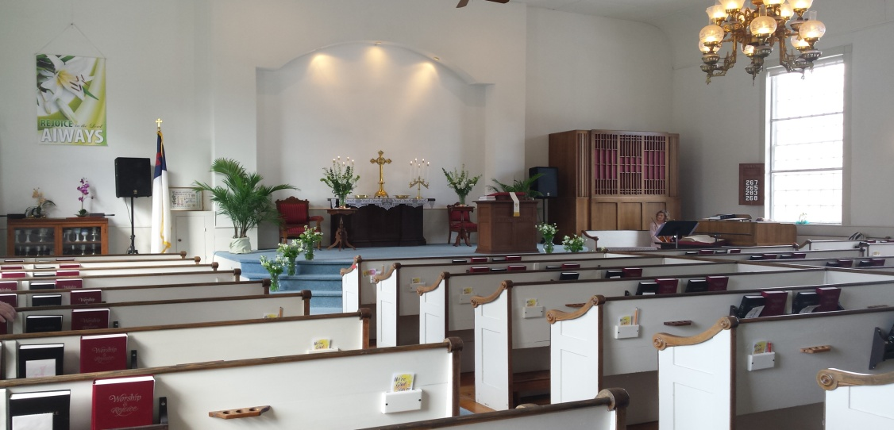

Awaiting your arrival….

